
President: Bruce VanDyke | Vice President: Jeremy Henson
Treasurer: Deana Watkins | Secretary: Cariann Anderson
Dear Whisper Woods Lot(s) Owner(s)
The Whisper Woods HOA association dues for 2026 are $500.00 per lot due April 1, 2026.
The association dues are used to pay for maintenance of our community, including street/grounds cleaning, paving, common grounds maintenance, infrastructure repairs, and community approved improvements.
A lien can and will be put on any lot that is not up to date on dues.
The HOA board is pleased to announce that we now have our very own website where we will keep information. Please remember we are volunteers and do the best we can. We are also pleased to announce that you now have options for paying online through the website for a small fee or you can still mail in a check to the P.O. Box. Please make checks payable to Whisper Woods HOA.
Details of all such expenses are discussed at our yearly community meeting. Our next community meeting will be an in-person meeting on May 2, 2026 at Lakeview Tavern at 11:00 AM.

www.whisperwoodshoa.com
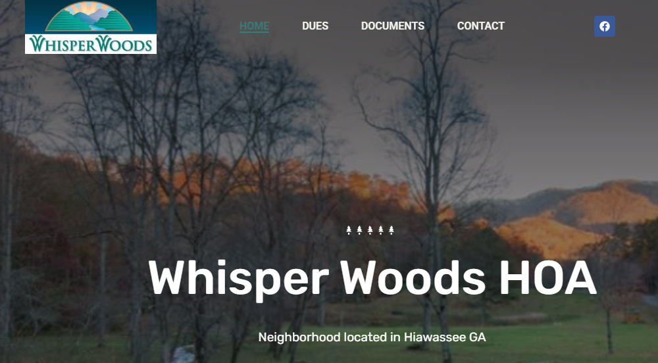
Whisper Woods Home Owners Association
NOTICE AND PROXY STATEMENT
Notice of Annual Meeting
Saturday, May 2, 2026----11:00 AM Lakeview Tavern, Hiawassee

Agenda for Annual Meeting
- Roll Call
- Reading of the Minutes of the 2025 Meeting
- Reports of Officers
- Old and Unfinished Business
- New Business
- Questions and Answers
- Adjournment

Sincerely yours,
Whisper Woods Home Owners Association
IMPORTANT: In the event you are unable to attend subject meeting, the HOA Board requests your proxy to act on your behalf at the 2026 Annual Meeting. Please sign your proxy and return to the Whisper Woods HOA PRIOR to the meeting on May 2, 2026. Your proxy is automatically rescinded by your presence at the Meeting; otherwise your proxy is needed for a quorum.

PROXY: I/We authorize President Bruce VanDyke or ______________________ to act on my/our behalf at the Annual Meeting of the Whisper Woods Home Owners Association on May 2, 2026.

SIGNED:__________________________________________________________________________

LOT Number:__________________________ DATE:_____________________________________

Email Adress:_____________________________________________________________________

WE need proxies in hand before May 1, 2026. Please send by mail or email.

